Assignment (Exception Handling)

1. **Write an object oriented code in Python, to download Gmail with attachments .**

**Create a "Emails.json" file**

**In "Emails.json" file, using Python `pickle` module, dump following information:**

**- subject**

**- date**

**- from email**

**- number of words and line in email body**

**- number of attachments**

**- name of attachments**

**Each like in "Email.json" should be a valid JSON**

Before creating the whole program, I created an app password for my gmail account to allow python to have an SSL session with my gmail account. App password allows us to sign in and use our mails, without the 2fa codes.

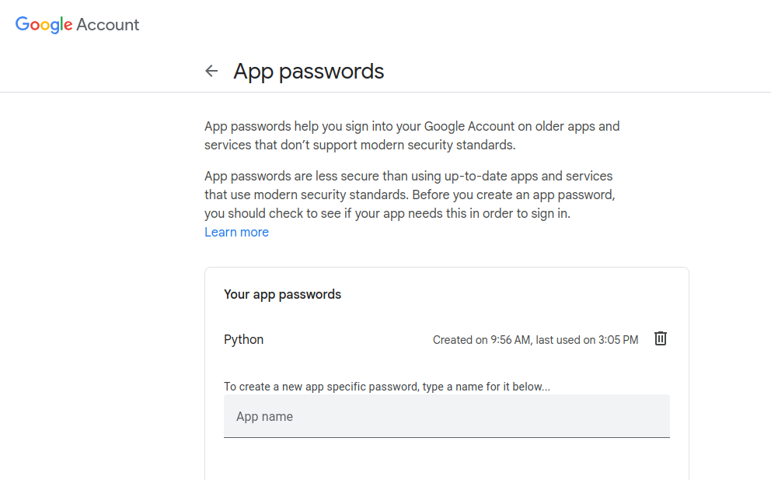

Created App Password

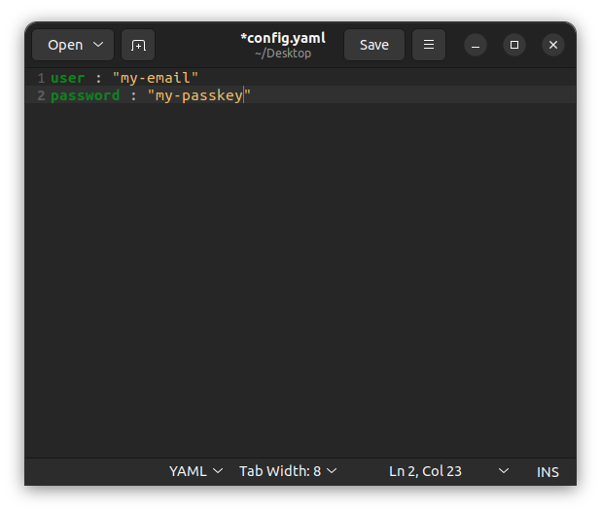

Created a YAML file for the credentials

Used .yaml file to store the credentials as the yaml library provides safe load of the credentials files

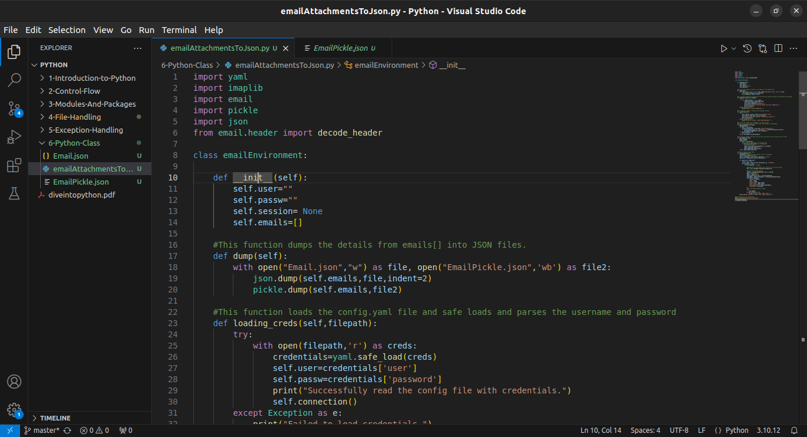

Code 1/4

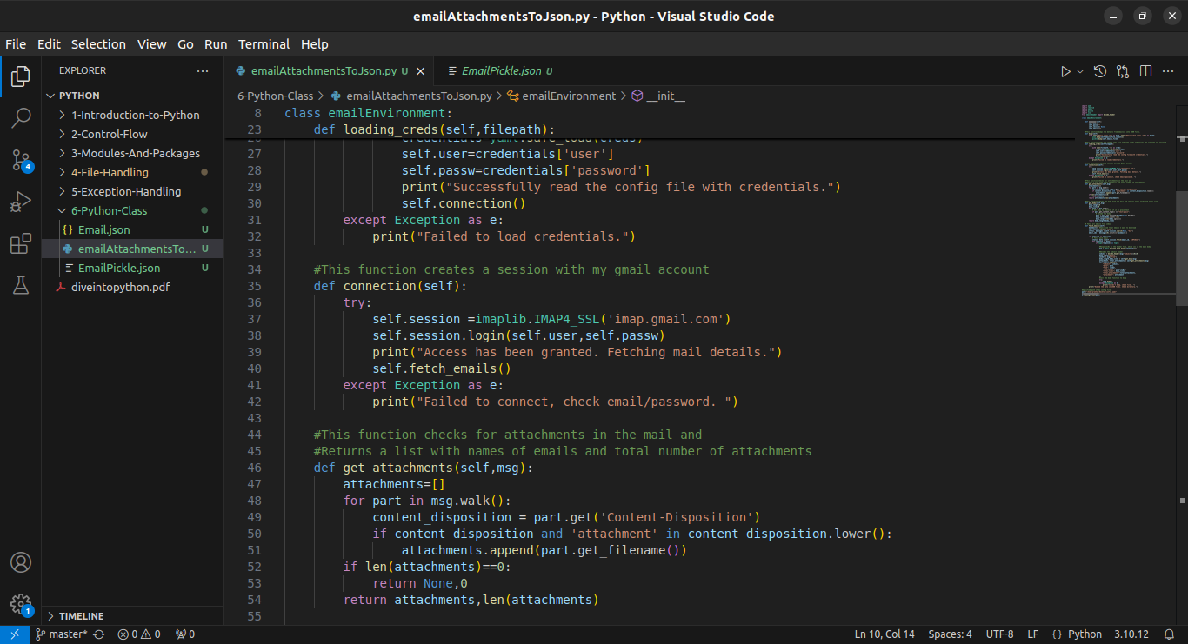

Code 2/4

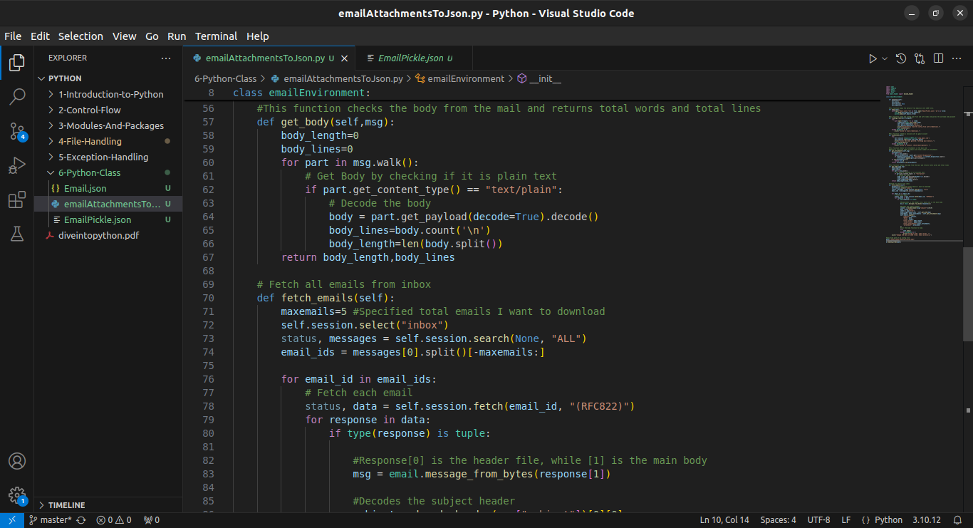

Code 3/4

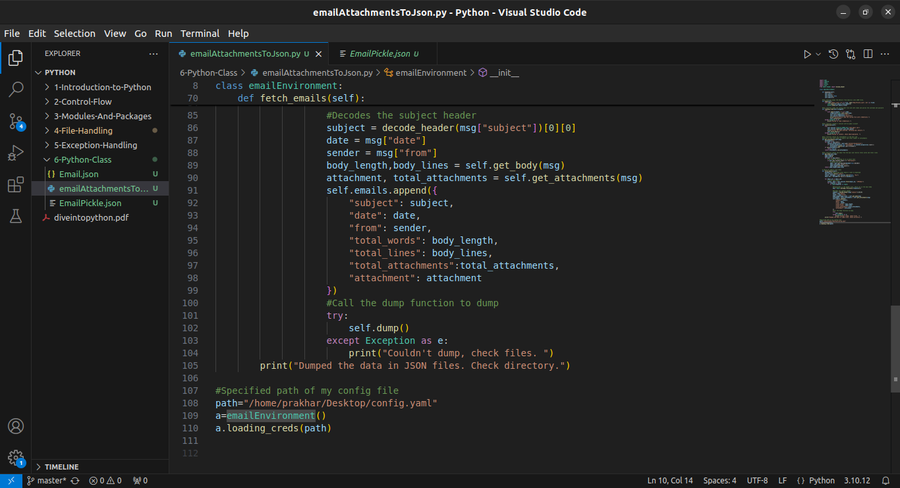

Code 4/4

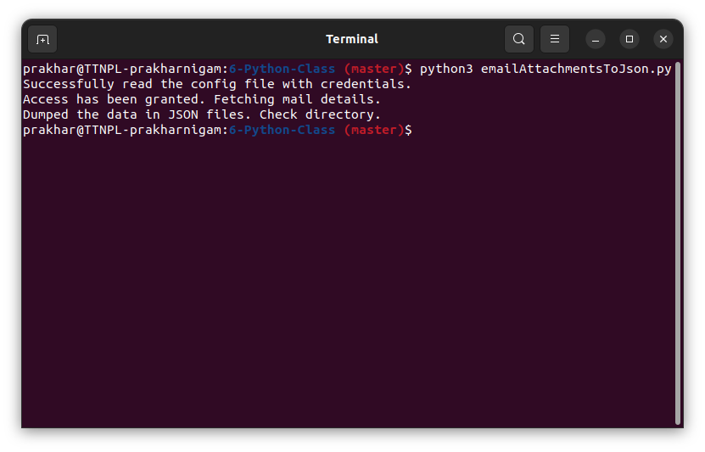

Execution of the files

I created 2 JSON files here, one dumped via pickle ( as mentioned in the question) and one

dumped via json (to ensure the working of the code by checking the emails stored)

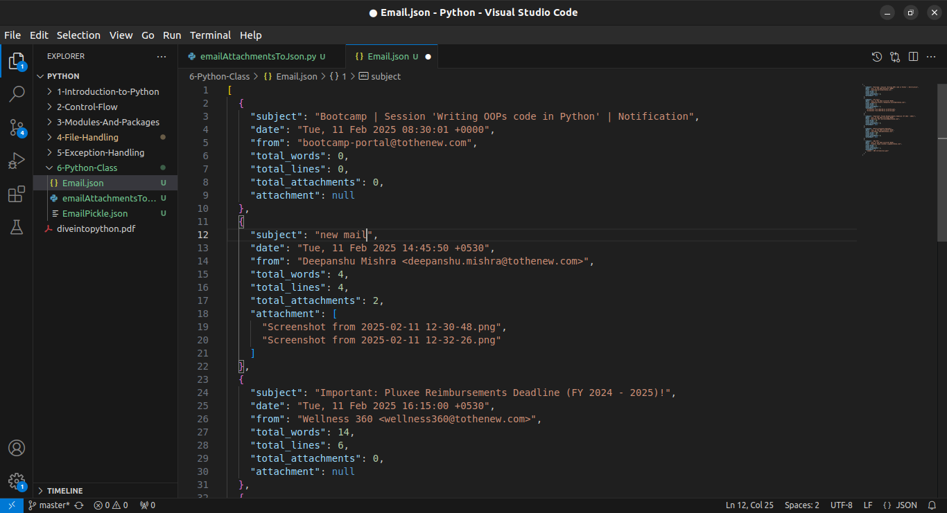

Output Dumped in JSON File

(via JSON.dump)

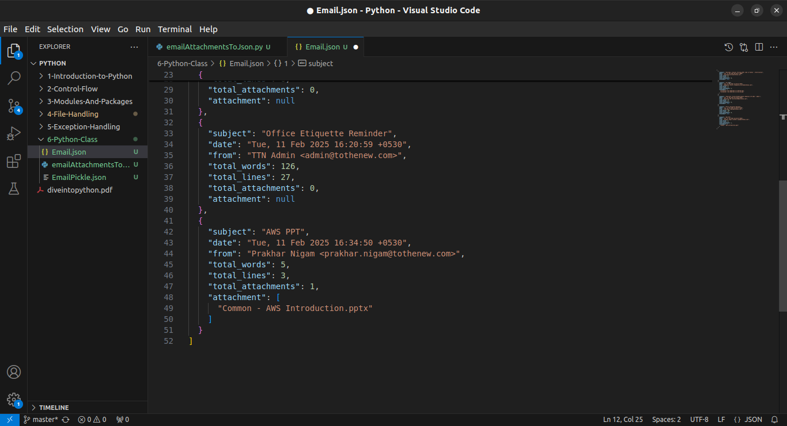

Output Dumped in JSON File

(via JSON.dump)

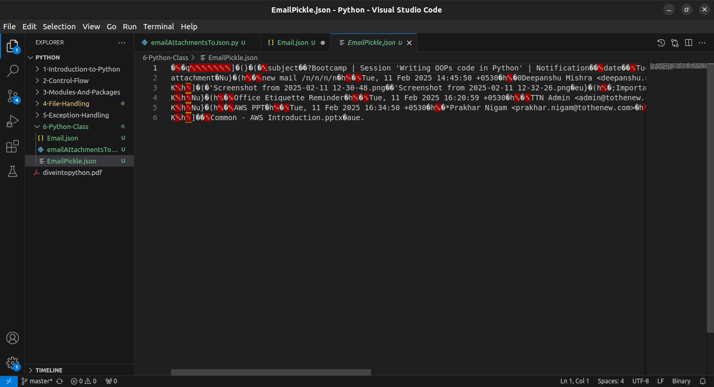

Output Dumped in JSON File

(via Pickle.dump)

1. **In download email assignment,**

**Provision to download only selective email. For example:**

**- To download only emails which have attachments**

**- To download only email which are related to Job**

**- To download only the email which have picture attached**

The majority of the code is as same as the previous question. Adding new changes done to the code

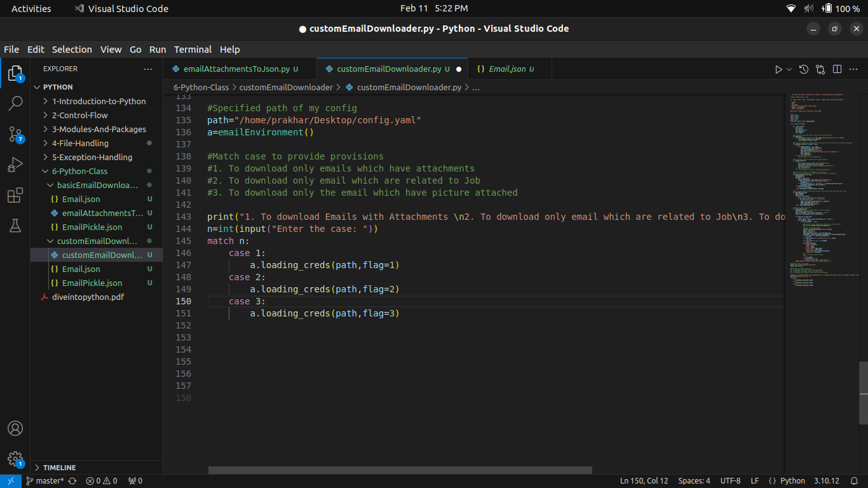

Added match case to provide provisions

If the flag is 1 which is mails w/ attachment. However if total attachments is 0, it will not append to final list.

If the flag is 2 which is Job emails. However if the sender's mail will not have a domain, it will not append to the final list.

In this flag is 3, which mails with images, in the hasImage variable has been passed from attachment functions, which is true if the mail has image. Providing if hasImage is false, it will not append

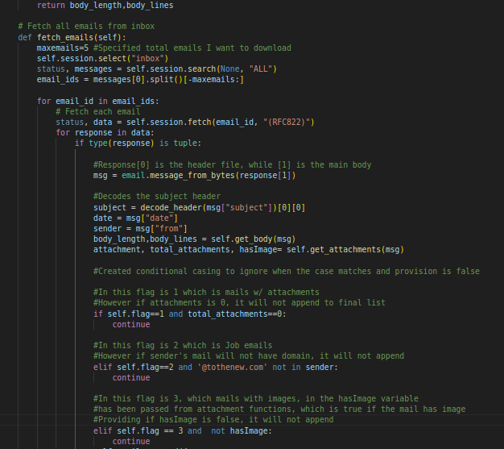

Added conditional statements to continue with the next iteration, if cases didn’t match

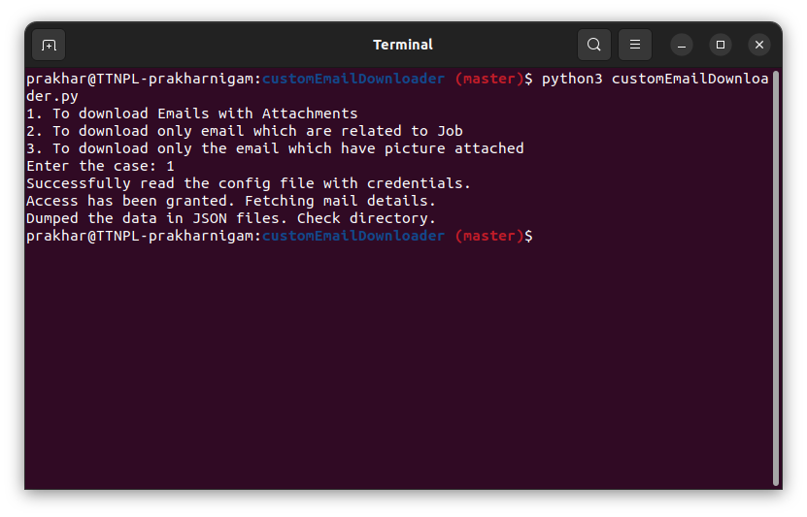

Case - 1

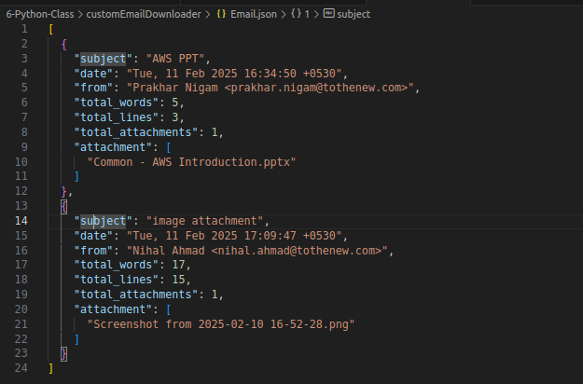

Output JSON File

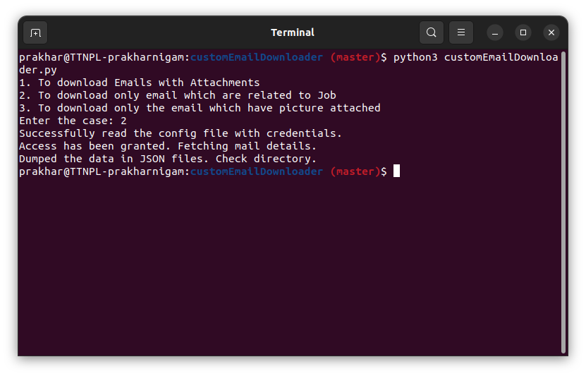

Case -2

[

{

"subject": "Office Etiquette Reminder",

"date": "Tue, 11 Feb 2025 16:20:59 +0530",

"from": "TTN Admin <admin@tothenew.com>",

"total_words": 126,

"total_lines": 27,

"total_attachments": 0,

"attachment": null

},

{

"subject": "AWS PPT",

"date": "Tue, 11 Feb 2025 16:34:50 +0530",

"from": "Prakhar Nigam <prakhar.nigam@tothenew.com>",

"total_words": 5,

"total_lines": 3,

"total_attachments": 1,

"attachment": [

"Common - AWS Introduction.pptx"

]

},

{

"subject": "New post shared!",

"date": "Tue, 11 Feb 2025 11:06:01 +0000",

"from": "Wellness 360 <newersworld@tothenew.com>",

"total_words": 0,

"total_lines": 0,

"total_attachments": 0,

"attachment": null

},

{

"subject": "Re: Knowledge Meet - February 2025 | Registrations Open",

"date": "Tue, 11 Feb 2025 17:00:00 +0530",

"from": "HR Support <hr-support@tothenew.com>",

"total_words": 761,

"total_lines": 110,

"total_attachments": 0,

"attachment": null

},

{

"subject": "image attachment",

"date": "Tue, 11 Feb 2025 17:09:47 +0530",

"from": "Nihal Ahmad <nihal.ahmad@tothenew.com>",

"total_words": 17,

"total_lines": 15,

"total_attachments": 1,

"attachment": [

"Screenshot from 2025-02-10 16-52-28.png"

]

}

]

Output JSON file

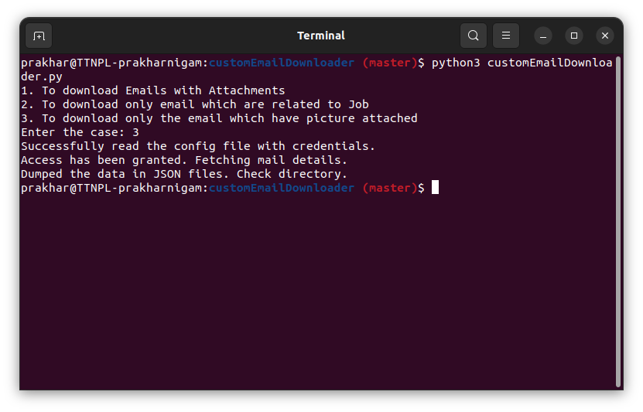

Case-3

[

{

"subject": "image attachment",

"date": "Tue, 11 Feb 2025 17:09:47 +0530",

"from": "Nihal Ahmad <nihal.ahmad@tothenew.com>",

"total_words": 17,

"total_lines": 15,

"total_attachments": 1,

"attachment": [

"Screenshot from 2025-02-10 16-52-28.png"

]

}

]

Output JSON File

1. **Implement a singleton class `Database` that ensures only one instance of the class can be created.**

A singleton class is a design pattern that ensures only one instance of a class is created, no matter how many times you try to create it. This is useful in situations where you want to make sure there's only one object managing a resource or process like a database connection, configuration settings, or a logging system.

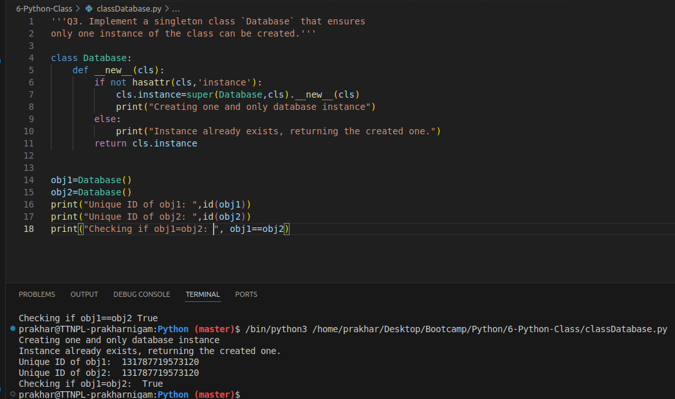

Here I created a class called ‘Database’ and defined the __new__ method to create instances.

I created a condition where it checks whether the class already has an instance, if it doesn’t it creates an instance and returns it else it returns the already existing instance.

I created multiple ways to check it, like printing when it created the first instance and printing when the instance already exists

Checking the unique id by using id() of the objects created and comparing them

All this to ensure only 1 instance is created.

1. **Python does not support method overloading directly. Implement a class MathOperations with a method add() that can handle both two and three arguments.**

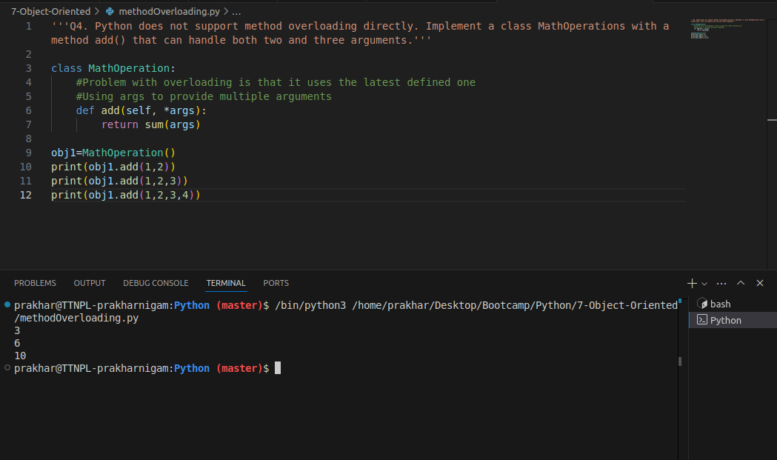

Overloading isn’t directly supported in python like it is supported in java or c++,

However python does provide us with args* argument which allows us to parse multiple or variable length of non-keyword argument which along with dynamic binding helps us introduce method overloading in python.